PYTHON PROJECTS “takeoff edu GROUP”

**Title**: Top 5 Python Projects for Engineering students

**URL**: https://takeoffprojects.com/python-projects

**Keywords**: Python Projects

**Description**:

Student searching for [Python Projects](https://takeoffprojects.com/python-projects)? Why to worry, Takeoff Edu Group is there to provide the best projects for students to enhance their knowledge for python projects.

Engineering Final Year Projects typically refer to academic projects undertaken by students in their final year of a Python Projects program.

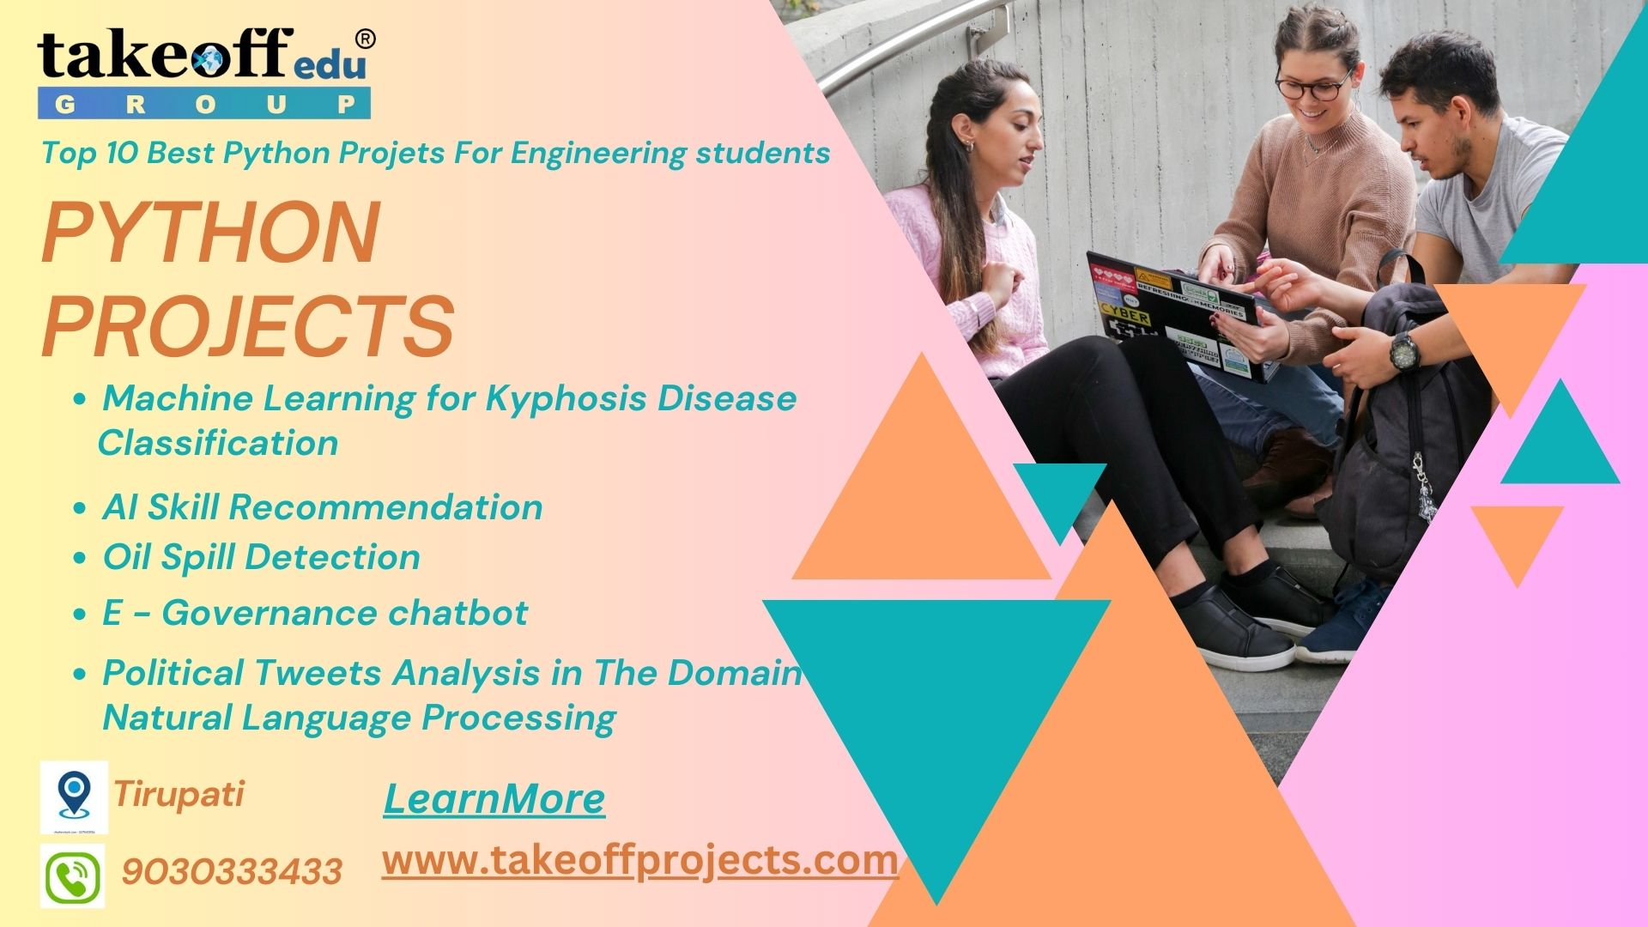

Certainly! Here are some project ideas using Python suitable for final year engineering projects:

**Smart Home Automation System**: Create a system that allows users to control home appliances remotely using Python along with Raspberry Pi or Arduino. Integrate features like voice recognition, scheduling, and sensor-based automation.

**Predictive Maintenance in Manufacturing**: Build a predictive maintenance system for machines in manufacturing units. Use machine learning algorithms in Python to predict equipment failure based on sensor data, reducing downtime.

**Energy Consumption Optimization**: Create a system to monitor and optimize energy consumption in buildings. Analyze data using Python to suggest efficient usage patterns and identify areas for improvement.

**Autonomous Drone or Robot**: Develop an autonomous drone or robot using Python and machine learning libraries. Enable it to navigate, make decisions, and perform tasks autonomously using sensors and cameras.

**Real-time Sentiment Analysis**: Create a tool using Python and Natural Language Processing (NLP) to perform real-time sentiment analysis on social media or news data. Visualize the sentiment trends for different topics.

**Python Projects Takeoff Edu Group**

Machine Learning for Kyphosis Disease Classification

AI Skill Recommendation

Oil Spill Detection

E - Governance chatbot

Handwritten Signature Recognition Using Deep Learning

Facial Recognition-Based Product Recommendation System Using Past Purc...

NTR Manasarovaram Park

Political Tweets Analysis in The Domain of Natural Language Processing

These are the”[**Python Projects**](https://takeoffprojects.com/python-projects)**”** designed for final year students. Takeoff Edu Group specializes in providing a diverse range of academic projects along with comprehensive subject knowledge and dedicated project assistance. With our expert guidance and resources, students can explore various project options and gain valuable insights into their chosen subjects.